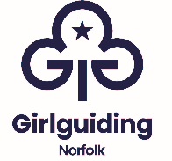
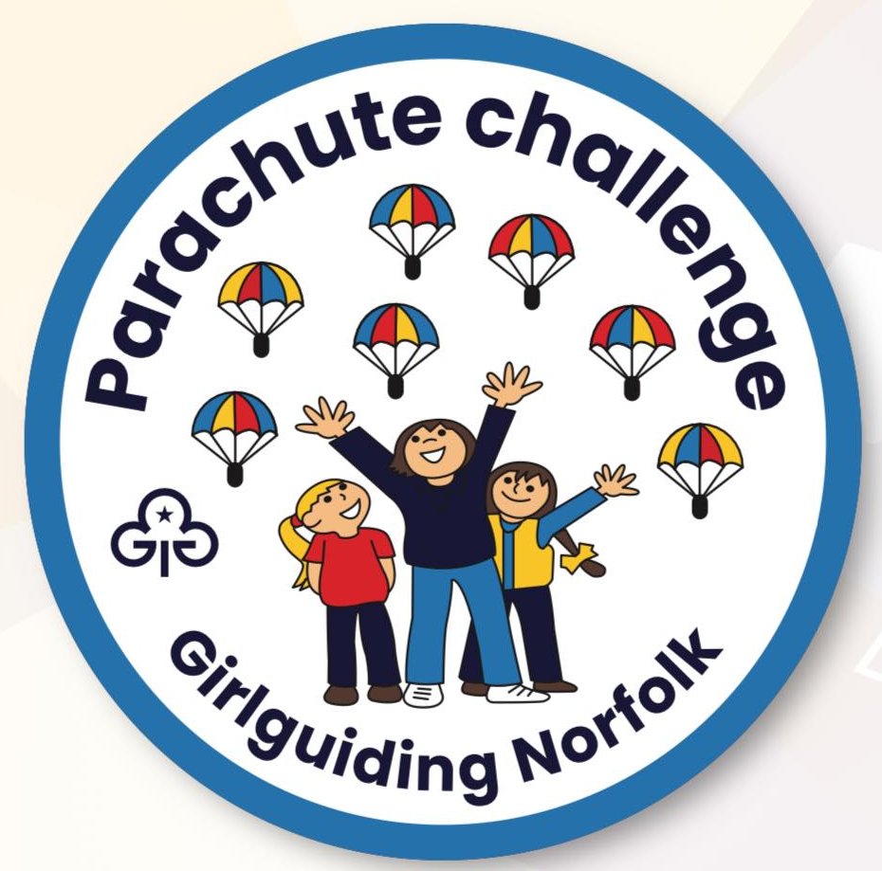

Girlguiding Norfolk Parachute Challenge

Girlguiding Norfolk Parachute Challenge

Introduction
Section 1 - Health and Exercise
Section 2 – Outdoor Fun
Section 3 – Games for All
Section 4 - Quiet Time
Section 5 - Activities
Leaders’ guide
How to Order Your Badges!

Introduction
Many years ago, we were given the opportunity by our local supermarket to purchase a piece of equipment for our Unit, we decided on a Parachute and a bag of plastic play balls as this was within budget, Our Leadership team had never run a Parachute activity and it came with no instructions. We very quickly researched this and learnt some basic games. We still have the original parachute although the balls have been replaced many times. This quickly became a favourite activity for our girls and over the years we’ve learnt many new games. The ideas are endless but we hope to have included some of your favourites and given you a few new ideas. Covid-19 has significantly and profoundly changed girls’ and young women’s lives over the course of 18 months. Mental health has been significantly impacted and it’s the girl’s happiness that now needs to be addressed. We think all girls should be encouraged to try new activities, discover new skills in a fun, friendly environment whatever their ability.
Enjoy and have fun!
Please complete as few or as many sections as you like. We hope you enjoy our challenge and would be very grateful if you’d purchase the badge, the proceeds of which will go towards Girlguiding Norfolk County events.

Leaders Guide - Parachute games are a fun way to teach children to follow instructions, they also learn the importance of sharing and interacting with one another. Games that involve the use of a parachute exercise the child’s arms and shoulder muscles. Most importantly, parachute games develop team-building skills, which help the children to socialize and make new friends. No matter what their age, they will surely enjoy parachute games. All they need is a parachute, a few balls, balloons or soft toys and you’re good to go. Parachute games can be used inclusively for all children, including those with a, disability, autism or other additional needs helping them develop teamwork skills. It can also help with gross motor skill development. These games enable participants to co-operate and take-turns with each other leading to an increase in confidence and social interaction. Rhythm, listening, communication and visual-auditory skills can also be developed.

Section 1 - Health and Exercise
1 - Merry-go-round
Simple commands like sit, stand, walk, and run can be taught round the Merry Go Round, ideal for children who need some physical exercise.
Ask the children to stand in a circle while holding the parachute with either the left or right hand, all must be facing one direction. The game leader should instruct the players to do as instructed: sit, stand, move, or pause. The result should be a beautiful merry-go-round formation by the girls.

2 - Beach-ball off the ground

Whether or not you are at the beach, playpark or garden, this game can be played just anywhere. All you need is a beach ball and a parachute.
For this simple game, start by holding the edges of the parachute.
Throw the ball onto the parachute. Flutter and wave the parachute into various directions but do not let the ball fall off.

3 - Spinning top

A participant sits in the middle of the parachute with their arms up. The others will then walk around holding the parachute and allowing it to partially cover the participant. After three, they will then pull the parachute towards them to enable the participant to spin around. Take care though she might be dizzy when she stands up!

4 - Fruit Salad

Each player is given the name of a fruit or vegetable (apple, cherry, pear or strawberry) (carrot, bean, sprout or leek). When the game leader calls out the name of a fruit, everyone with this fruit must swap places by running under the parachute. When fruit salad is called out, everyone must swap places with the players on the other side. You’ll need a couple of taller girls/Leaders to hold on to the parachute.

Section 2 – Outdoor Fun
1 – Jumping Beans
You’ll need your parachute and small, lightweight plastic balls, ball pit balls are perfect, just call them beans for this game.
Ask the girls to hold all the edges of the parachute firmly and hold the parachute still.
Place all the balls on top of the parachute.
The task is to vigorously shake the parachute until all the balls fly off it.
The next bit is to see how quickly all the balls can be picked up off the floor.
Having a timer would make the game a lot more fun.

2 - 5 Little Monkeys Jumping On The Bed

You’ll need 5 “monkeys” so monkey puppets or toys, or you could just use something like beanbags to represent them.
Throw one at a time onto the parachute, and count them -1, 2, 3.. as they land on the parachute. Then bounce them to the beat of the music as you sing:
“5 Cheeky monkeys jumping on the bed
One fell off and bumped its head
Mum phoned the doctor and the doctor said,
‘No more monkeys jumping on the bed!’”
Take one off and count how many you have left. Repeat the song, taking off one monkey each time.
Top tip – There are lots of other counting songs you could use eg. 5 Little Ducks, and 5 Little Men in a Flying Saucer
[Grab your reader’s attention with a great quote from the document or use this space to emphasize a key point. To place this text box anywhere on the page, just drag it.]

3 - Parachute tug-of-war
The parachute tug-of-war game is a quick fun game.
Divide the number of players into two teams.
Ask the teams to stand on two sides of the parachute, holding it firmly.
Begin the game on the count of 3.
The task is to pull the opposite team onto their sides.
Whoever accomplishes this goal fastest wins the game.

4- Shark Attack

This is really good fun. It is a bit like a revamped version of the classic game Duck, Duck, Goose.
You get the children to all hold onto the parachute, apart from one child who will go underneath the parachute. They are the shark. They lie on the floor beneath the parachute.
The children then make the waves of the sea with the parachute, gently going up and down above the shark’s head.
The ‘shark’ will then ‘swim’ around in the sea, until they choose a child’s leg to tap. (Remind them to do it gently). That child will then run all the way around the parachute, back to where they started and then go under the parachute, swapping places with the shark. They are the new shark. Repeat.
Section 3 – Games for All

1 -Parachute Party

Hold a parachute party, complete the challenge in one session perhaps. Make parachute theme cakes, pizza, sandwiches. Make table decorations. Ask your Unit for ideas.

2- Shaking popcorn
Place beanbags or balls on to the parachute, the girls can shake the parachute to make the beanbags rise and jump like popcorn.
3– Mushroom
Participants lift the parachute high above their heads and then sit on the inside edges of the parachute to create a "mushroom." We found once under there the girls were often happy to just sit and chat for a short while.

4- Row Row Your Boat

Let the children sit on the floor holding the edge of the parachute whilst you all sing the song, all ‘rowing’ backwards and forwards. Some of the many other good verses include:
If you see a little mouse
Don’t forget to squeak! (Do lots of squeaking!)
If you see a crocodile
Don’t forget to scream! (Scream!)
If you see a lion
Don’t forget to roar! (Roar!)

5– Who Let Go!!

Hold on to the edge of the parachute and slowly start your rhythm of up and down, getting a little stronger and faster each time when the rhythm is good and on an “up” call out LET GO! The parachute should float higher before it comes down.

6- Who Am I?
Ask the girls to stand around a parachute and close their eyes. Then the game leader taps one child on the shoulder. Whoever has been tapped must hide under the parachute. Then everyone opens their eyes, and the mystery child says ‘Who am I?’ Everyone tries to guess who is missing. Make this one more difficult by suggesting they put on a silly voice to disguise who they are.
7- Action songs
The parachute is used as an aid during action songs. For example with the song ‘Grand old Duke of York,’ participants can hold the parachute high when “soldiers” are up and low for when the “soldiers” are down.
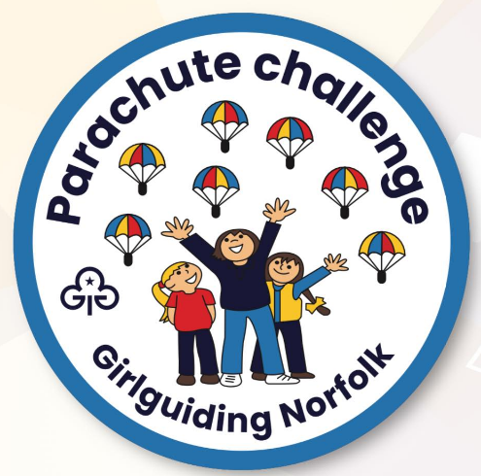

Section 4 - Quiet Time

1 - Story-telling
Girls will make movements, up and down, side to side with the parachute to represent parts of a story or poem e.g. "sea waves” or “umbrella.” ( we need to make more of this!!)
2 – Decorate a cake or a Pizza to look just like a parachute.
3 – Make a Parachute for an egg – raw! Hard boiled or perhaps a Chocolate egg.

4 - Colour in your ideal parachute, don’t forget to add the handles!

5 - Everybody’s Sleeping
What a lovely way to finish off the evening and also the challenge. Everyone lies down and ‘goes to sleep’ under the parachute. Here is a little song that you whisper quietly:
Everyone is sleeping, Sh! Sh! Sh!
Night night, sh! Night Night Sh!
Perfect as a warm-down

.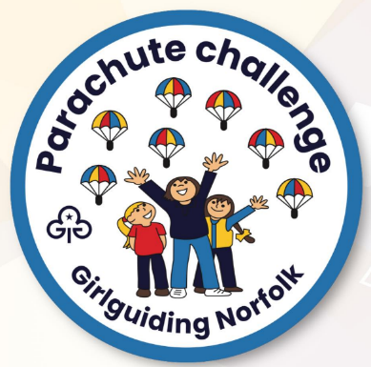

5 – Activities & Craft

1 – Colour in your ideal parachute, don’t forget to add the handles!

2 – Design your own parachute for a small toy, Playmobil or lego person are a good size, you can use a cupcake case, a coffee filter, a napkin, there are no end of ideas online, Pinterest etc or come up with your own. See how far they will fall without breaking!

3 – Find as many words as you can from the word – PARACHUTE

4 – Have a go at Paracord crafts. Online you’ll find lots of suggestions under Parachute cord, lots of ideas for all ages but perhaps more suitable for Guides and Rangers.
5 – Research the History of the Parachute, there are many stories of people trying to fly over the centuries. Discuss how exciting it would be to fly like a bird or an insect. Where would you fly to and what would you like to see from the sky?
6 – Hold a Parachute party, make brightly coloured cupcakes or biscuits, perhaps invite another Unit and show them the Parachute Games you’ve learnt, which ones are your favourite?

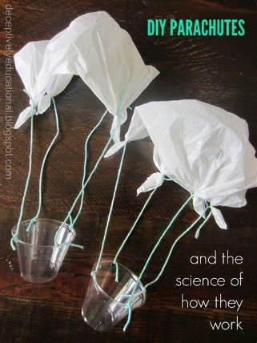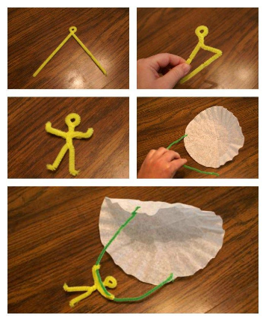

To Order your Badges – Please order from our County Online Shop : Girl Guiding Norfolk Shop
Postage will be applied on your way through checkout.

Parachute Colouring, don’t forget to add the Handles! Copy and paste to then make larger.



