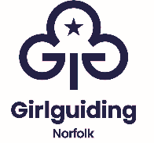

Branded Promotional Items for Hire
The following promotional items are available to hire for events from Patteson Lodge, free of charge, to book and arrange collection, please contact ggnadmin@girlguidingnorfolk.org.uk

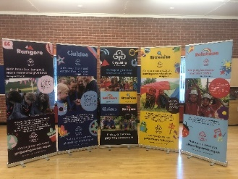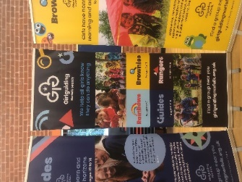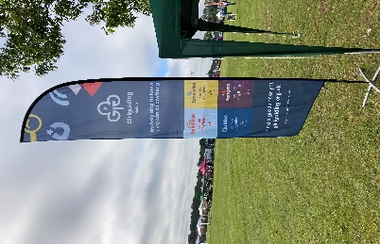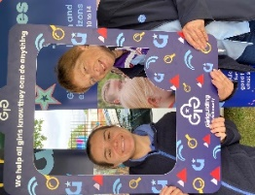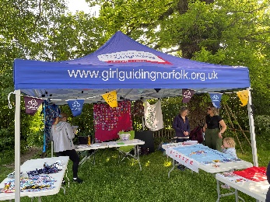
Sail Banner (Red) | Pull up Banner Rainbows | Table Cloth Gazebo
Sail Banner (Blue) | Pull up Banner Brownies | Selfie Frame
Sail Banner (Green) | Pull up Banner Guides
 | Pull up Banner Rangers
 | Pull up Girlguiding General

